***Finding The Right Neighborhood For A New Restaurant***

**Christopher Guillotte**

**April 23, 2021**

**Introduction**

New Orleans is considered an economic and commercial hub for the broader Gulf Coast region of the United States. It is world-renowned for its distinct music, distinct language, its annual celebrations and festivals, most notably Mardi Gras, and its great cuizine. Districts and neighborhoods can be tough to navigate as venues change drastically from block to block. Having some insight into the different communities in New Orleans could help in determining the best location for a new restaurant.

**Problem**

We will use clustering to gain insights on the different neighborhoods in new orleans based off of available venues. We will use this to try to make informed decisions on where to open a new restaurant.

**Data**

We will be using the information from [this](https://en.wikipedia.org/wiki/Neighborhoods_in_New_Orleans) wiki for neighborhood names and locations. We will also be using the FourSquare API to information about different venues near Neighborhoods. Here is a image of the map of all neighborhoods in the data.

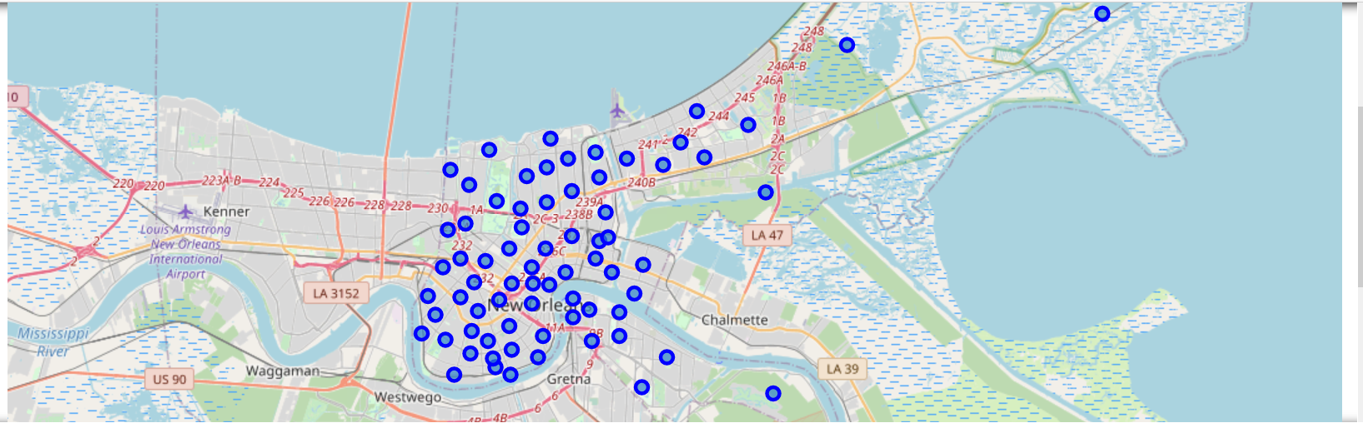

**Data Cleaning**

The Neighborhood data in the wiki was well suited for the task at hand and was easily imported into a dataframe using beautiful soup. The four square data had to be modified to only give the name, categories, longitude, and latitude of each venue.

**Data Verification**

After cleaning there are 4280 venues that are included in the 72 neighborhoods in New Orleans. All seem to have appropriate information with no missing data. We then got the 10 most common venue types for each neighborhood. Here is an example of the first 5 neighborhoods :

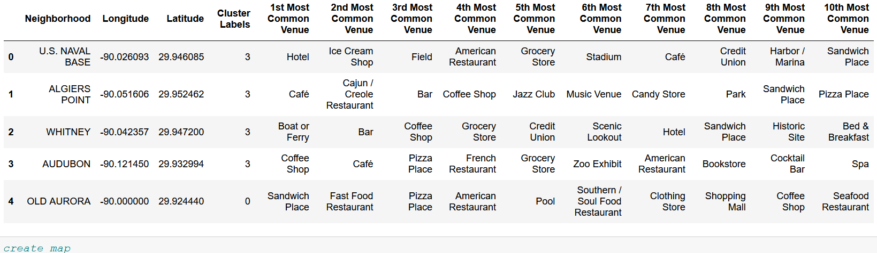

Clustering

Next we cluster those neighborhoods by venues to see what insight we can derive.

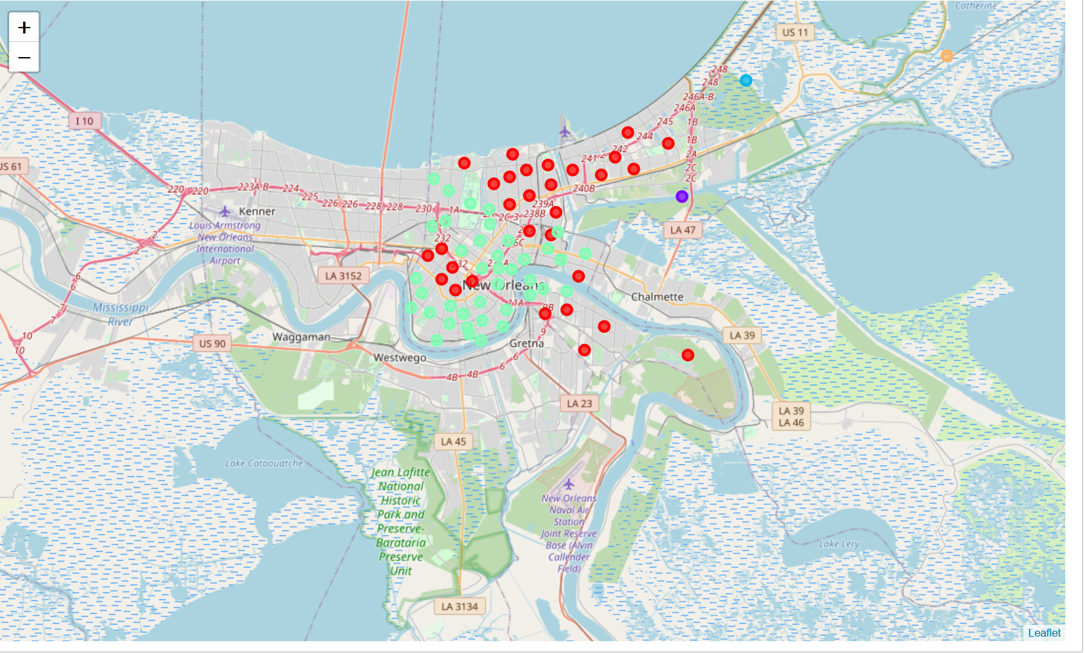

Lets look at the data for each individual cluster.

Cluster 1:

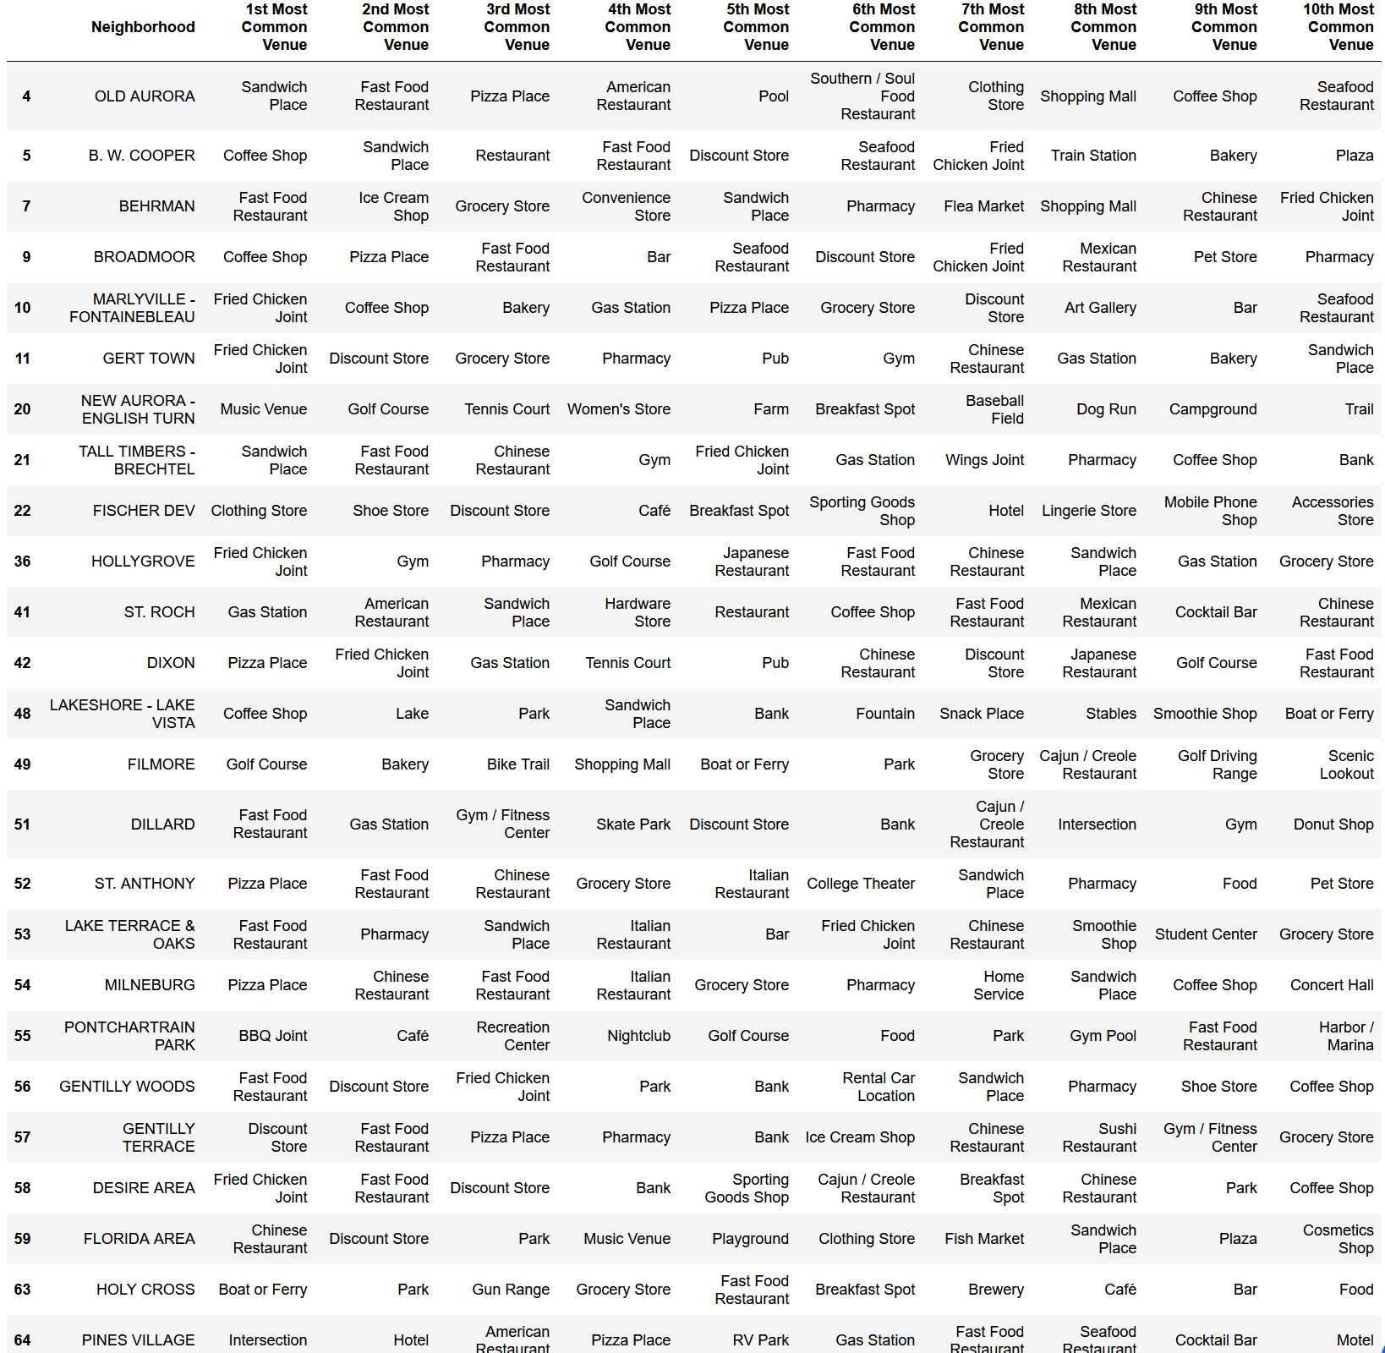

Cluster 2:



Cluster 3:



Cluster 4:

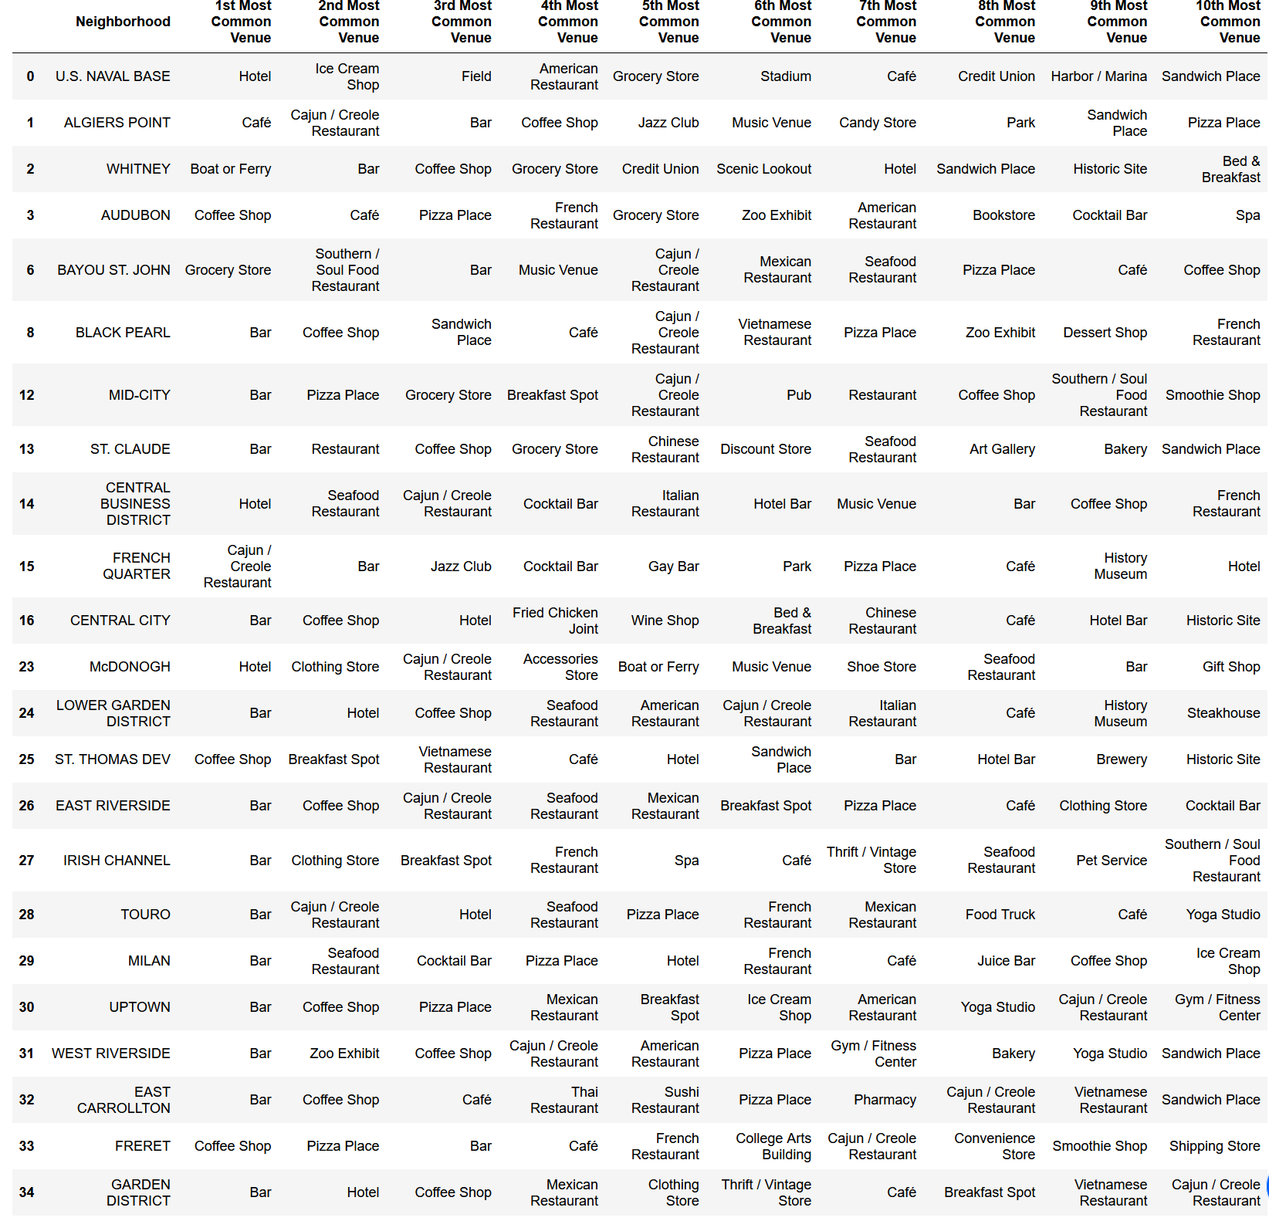

Cluster 5:

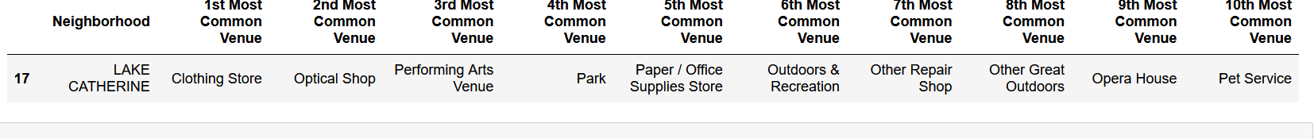

**Analysis**

First let's look at the obvious data points. Clusters 2, 3, and 5 only have a single neighborhood. Let's explore those to see if they are a good fit as unique areas in the city or not. **Cluster 2** contains the growing community of Viavant-Venetian Isles. This is a growing community whose main venues are seafood restaurants, parks, and performing arts centers. This could be a great place for a new restaurant.

**Cluster 3** contains the neighborhood of Village de Lest. It is in the relatively undeveloped Eastern New Orleans however, Village de L'Est is one of the few densely-developed neighborhoods in the area. It is known for its Vietnamese community. The Vietnamese community, sometimes being called "Little Vietnam". The area hosts a number of Vietnamese restaurants, including the famous Dong Phuong Restaurant & Bakery. This could be a viable place for a new restaurant depending on the cuisine.

**Cluster 5** contains Lake Catherine which is mostly undeveloped wetland that is technically in the city limits. It is not densely populated and would probably not be a good area to start a new restaurant.

Cluster 1 and 4 are where the majority of the neighborhoods are located. **Cluster 1**, with its abundant stores, fast food places, and coffee shops, seems to be the residential areas around the city. These areas could be great if you want a restaurant that is a hot spot for local residents or workers on lunch break.

Finally, **cluster 4** seems to be the entertainment districts. They are filled with bars, restaurants, cafe’s, etc. If you want to capture the New Orleans night life with your restaurant these are the places to go.

**Results**

The clustering process helped narrow down the search based on the target customer of the restaurant. We have shown some areas that are very unique which may be capitalized on, as well as the more common places that restaurants are opened. If needed we could do further analysis and clustering on the neighborhoods in a given cluster to further refine the choices if that is needed.